**[2CEIT503: COMPUTER NETWORK]**

Practical: 7



**AIM: Implementation of .tcl script in Ns2 .**

**a) Write a tcl script to add two nodes and one link (example.tcl).**

**b) Modify example.tcl such that node n0 sends data to node n1.**

**Department of Computer**

**Engineering/Information Technology**

1. **Write a tcl script to add two nodes and one link (example.tcl).**

set ns [ new Simulator ]

set nf [ open p7q1.nam w ]

$ns namtrace-all $nf

set n0 [$ns node]

set n1 [$ns node]

$ns duplex-link $n0 $n1 1Mb 10ms DropTail

proc finish {} {

global ns nf

$ns flush-trace

close $nf

exec nam out.nam &

exit 0

}

$ns at 5.0 "finish"

$ns run

**Output:**

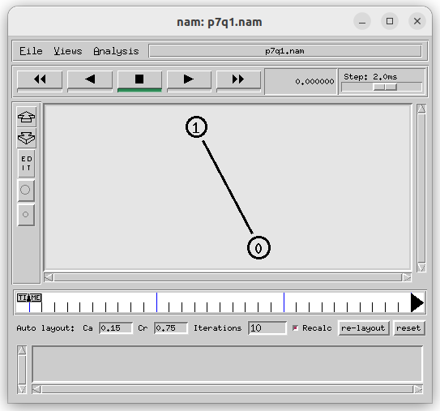

**b) Modify example.tcl such that node n0 sends data to node n1.**

set ns [ new Simulator ]

set nf [ open p7q2.nam w ]

$ns namtrace-all $nf

set n0 [$ns node]

set n1 [$ns node]

$ns duplex-link $n0 $n1 3mb 5ms DropTail

set udp0 [new Agent/UDP]

$ns attach-agent $n0 $udp0

set cbr0 [new Application/Traffic/CBR]

$cbr0 attach-agent $udp0

set null0 [new Agent/Null]

$ns attach-agent $n1 $null0

$ns connect $udp0 $null0

proc finish {} {

global ns nf

$ns flush-trace

close $nf

exec nam out.nam &

exit 0

}

$ns at 1.0 "$cbr0 start"

$ns at 8.0 "$cbr0 stop"

$ns at 10.0 "finish"

$ns run

**Output:**

